43.68: The activity of the sample will have decreased by a factor of
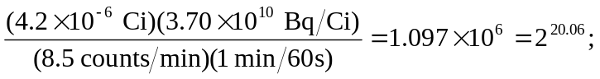
this corresponds to 20.06 half-lifes, and the elapsed time is 40.1 h. Note the retention of extra figures in the exponent to avoid roundoff error. To the given two figures the time is 40 h.

